|  |  |
| --- | --- |
| Contact: Jesse Dickin  Gymnastics Adventure  Phone 306-789-3133  Fax 306-789-3533  [jesse@gymadv.ca](mailto:jesse@gymadv.ca) | 210 Leonard St  Regina, SK S4N 5V7 |

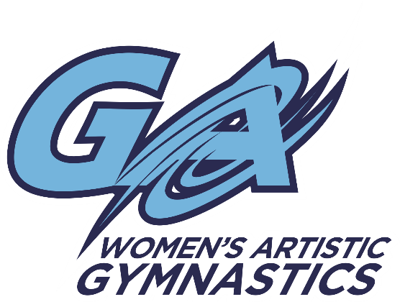

Upcoming Competition

# Yorkton Gymnastics

## Springers Invitational

Yorkton, SK. April 1-3, 2016

**Location:** Yorkton Regional High School

**$85.00 J.O. Level 3-5**

**$50.00 J.O. Level 1-2**

**Registrations and waiver are due on or before** **February 26, 2016**

* Please make cheques payable to Gymnastics Adventure
* Any registrations received after **February 26th will be subject to a $20.00 late fee**
* Please see attached in email for waiver. We will also have extras pinned to the bulletin board by the mailboxes at the gym.
* Tentative Schedule:   
  (subject to change once all registration is received)
  + Saturday, April 2, 2016
    - Morning: J.O. Level 1
    - Afternoon: J.O. Level 2
    - Mid-afternoon: J.O Level 4/5
    - Evening: J.O. Level 3
* **Near by Hotels:**
  + Holiday Inn Express

63 7th Ave N.  
Yorkton, SK S3N 3X2  
306-782-9888

* + Days Inn & Suites

275 Broadway St. East  
Yorkton, SK S3N 0N5  
306-782-3112