|  |  |
| --- | --- |
| Contact: Jesse Dickin  Gymnastics Adventure  Phone 306-789-3133  Fax 306-789-3533  [jesse@gymadv.ca](mailto:jesse@gymadv.ca) | 210 Leonard St  Regina, SK S4N 5V7 |

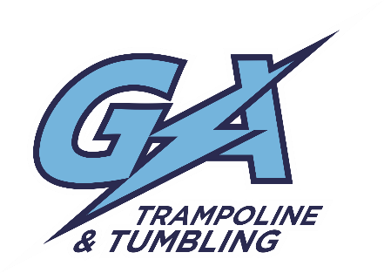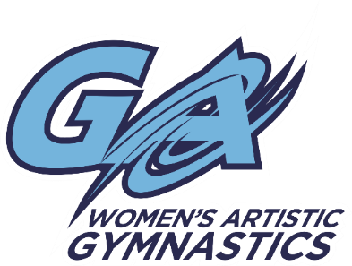

Upcoming Competition

# GYMNASTICS SASKATCHEWAN

## Presents 2016 Provincial Championships

Yorkton, SK May 12-15, 2016

**Location:** Nexera Flexihall

455 Broadway St. West, Yorkton, SK

* North building of the Gallagher Centre.
* The Gallagher Centre also houses the Farrell Agencies Arena, Waterpark with waterslides, and conference facilities. The Gallagher Centre is across from the Painted Hand Casino and the host hotel, Home Suites.

**$120.00 for all competitive athletes**

**Registration and waiver are due on or before** **April 18th, 2016**

* Please make cheques payable to Gymnastics Adventure
* Any registrations received after **April 18th will be subject to a $25.00 late fee**
* Please see attached in email for waiver. We will also have extras pinned to the bulletin board by the mailboxes at the gym.
* Tentative Schedule:   
  (subject to change once all registration is received)
  + **WAG:**
    - Friday, May 13
      * Session 1 12:00-4:00 J.O. Level 3 (2006-2007)  
        Session 2 4:00-8:00 J.O. Level 3 (2005+)
    - Saturday, May 14
      * Session 3 8:00am-12:00pm J.O. Level 4 &5
  + **T&T:**
    - Friday, May 12
      * Session 1 12:00-4:00 Open Gym  
        Session 2 4:00-8:00 P3-Nat Prelims
    - Saturday, May 13
      * Session 3 8:00am-12:00pm P1-2 Prelims  
        Session 4 12:00-4:00 P3-Nat Finals  
        Session 5 4:00-8:00pm P1-2 Finals
* **Merchandise:**

There will be an event hooded sweatshirt available for purchase prior to the event. More details will be emailed out closer to the event

* **Near by Hotels:**
* Days Inn & Suites Yorkton  
  275 Broadway St E  
  306-782-3112  
  [www.daysinn.ca/yorkton](http://www.daysinn.ca/yorkton)  
  Rooms blocked until April 12th (starting at $125.99)
* Holiday Inn Express Yorkton  
  63 7 Ave N.  
  306-783-9888  
  [www.hiexpress.com/yorkton](http://www.hiexpress.com/yorkton)  
  Rooms blocked until April 12th ($119.00)