|  |  |
| --- | --- |
| Contact: Jesse Dickin  Gymnastics Adventure  Phone 306-789-3133  Fax 306-789-3533  [jesse@gymadv.ca](mailto:jesse@gymadv.ca) | 210 Leonard St  Regina, SK S4N 5V7 |

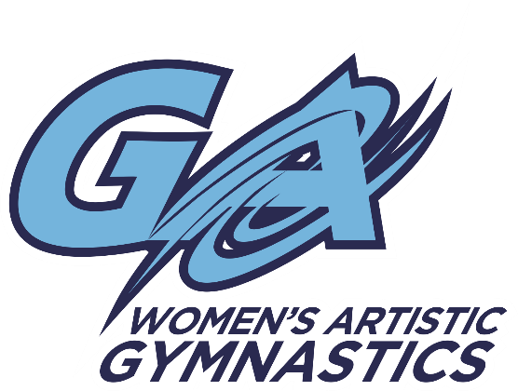

Upcoming Competition

# QCK GYMNASTICS CLUB

## WAG Invitational

Regina, SK. April 8-10, 2016

**Location:** QCK Gymnastics Club

5025 Tiger Moth Lane Regina, SK. S4W 1B4

**$90.00 JO Level 3-5**

**$50.00 JO Level 1-2**

**Registration are due on or before** **March 1, 2016 *No waiver needed\***

* Please make cheques payable to Gymnastics Adventure
* Any registrations received after **March 1st, 2016 will be subject to a $50.00 late fee**
* No waiver needed
* Tentative Schedule:   
  (subject to change once all registration is received)
  + Friday, April 8, 2016
    - 5:30-9:30pm J.O Level 4-5
  + Sunday, April 10, 2016
    - 9:00am – 12:30pm J.O. Level 3
    - 1:00-4:00pm J.O. Level 2
    - 4:00-7:00pm J.O. Level 1