|  |  |
| --- | --- |
| Contact: Jesse Dickin  Gymnastics Adventure  Phone 306-789-3133  Fax 306-789-3533  [jesse@gymadv.ca](mailto:jesse@gymadv.ca) | 210 Leonard St  Regina, SK S4N 5V7 |

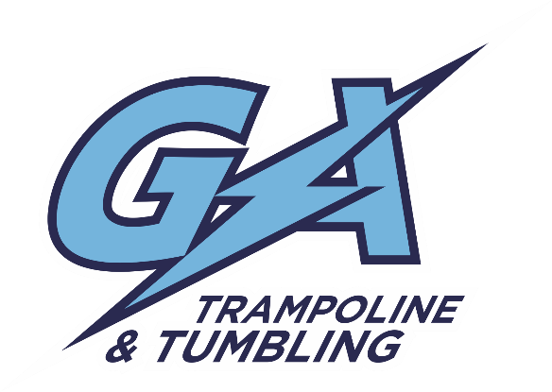

Upcoming Competition

# PRAIRIE INVITATIONAL

## Gym Adventure TTG Competition

Regina, SK. April 1-3, 2016

**Location:** Gymnastics Adventure

210 Leonard St. Regina, SK. S4N 5V7

**$90.00 Provincial/ National Level (2+ event)**

**$60.00 Fast Cat/ Provincial Level (1 event)**

**Registration is due on or before February 25th, 2016**

* Please make cheques payable to Amazing Adventures
* Any registrations received after **February 25th will be subject to a $20.00 late fee**
* Tentative Schedule:
  + Friday April 1, 2016

Open Training 2:00-4:00pm

Run & Stretch 5:00pm-5:30pm

Tumbling: LEVEL 3-5

DMT: LEVEL 4-6

* + Saturday April 2, 2016

Run & Stretch 9:00-9:30am

Synchro: ALL LEVELS

Tramp: ALL LEVELS

DMT: LEVEL 1-3

Tumbling: LEVEL 1-2

* + Sunday April 3, 2016

Run & Stretch 9:00-9:30am

Fast Cat: ALL LEVELS