|  |  |
| --- | --- |
| Contact: Jesse Dickin  Gymnastics Adventure  Phone 306-789-3133  Fax 306-789-3533  [jesse@gymadv.ca](mailto:jesse@gymadv.ca) | 210 Leonard St  Regina, SK S4N 5V7 |

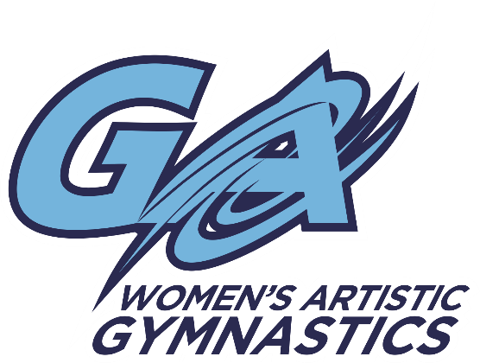

Upcoming Competition

# PRINCE ALBERT AERIALS

## Presents the 2016 Aerials Survivor

Prince Albert, SK. February 26-28, 2016

**Location:** Prince Albert Aerials Gymnastics Club

1150 3rd Avenue West, Prince Albert, SK. S6V 5G3

**TTG: $55.00 for 1 event or $90 for 2-3 events**

**Registrations and waiver are due on or before** **January 22, 2016**

* Please make cheques payable to Gymnastics Adventure
* Any registrations received after **January 22nd will be subject to a $20.00 late fee**
* Please see attached in email for waiver. We will also have extras pinned to the bulletin board by the mailboxes at the gym.
* Map to Competition can be found at [www.paaerials.ca](http://www.paaerials.ca)
* Schedule and session groupings will be released once registration has been received