**OPTIONAL Conditioning & Flexibility**

This sheet was done upon request of many parents, and is completely optional.

**General Conditioning:**

* 20 push-ups
* 20 sit-ups
* 20 squats
* 1 minute handstand hold (tummy against wall)
* 20 leg lifts (on floor)
* 20 frog jumps on the spot
* 20 back lifts (on stomach)
* 20 tricep dips (hands on bench)
* 1 minute front support hold (leaning over hands)
* 20 lunges each leg
* 20 calf raises on stairs 3x
* 30 second L-hold (on bench)
* 30 second incurve/outcurve hold
* 20 tuck snaps

**General Flexibility**

* 30 second standing pike hold
* 30 second sitting pike hold
* 1 minute straddle hold
* 10 kicks each leg (on ground or standing)
* 10 second bridge hold 3x
* 1 minute right leg split
* 1 minute left leg split
* 1 minute middle split

**Shoulder Flexibility**

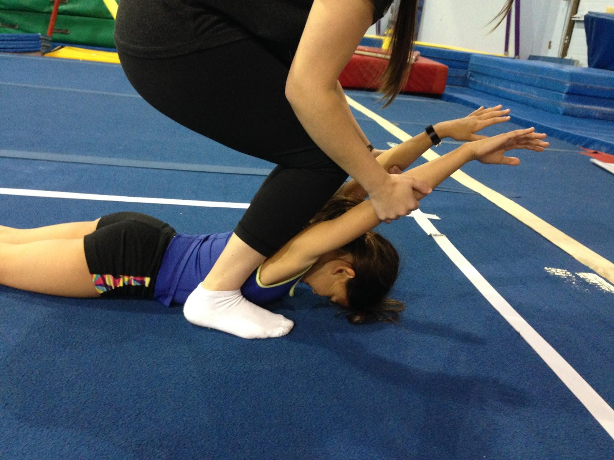

Start with arms by ears, and lift straight up until they feel a stretch

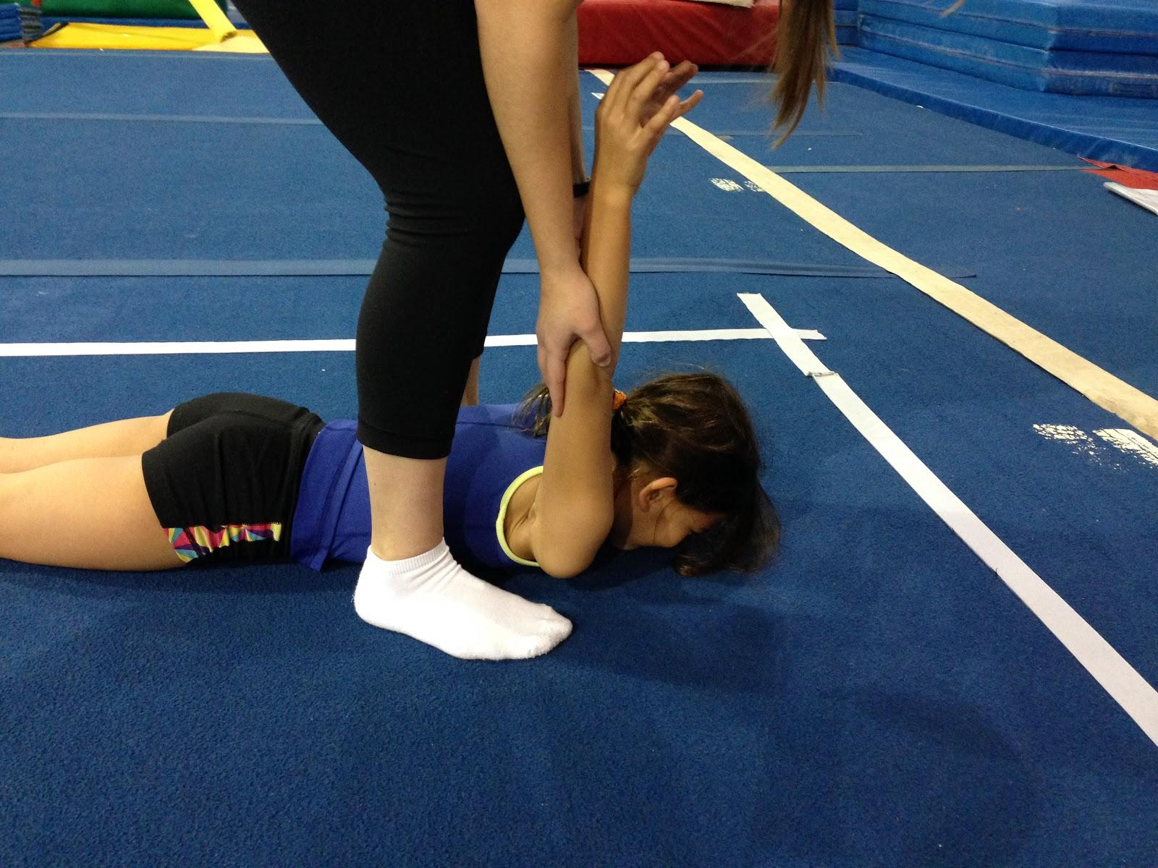

Start with arms by sides, and lift straight up towards the head, until they feel a stretch.

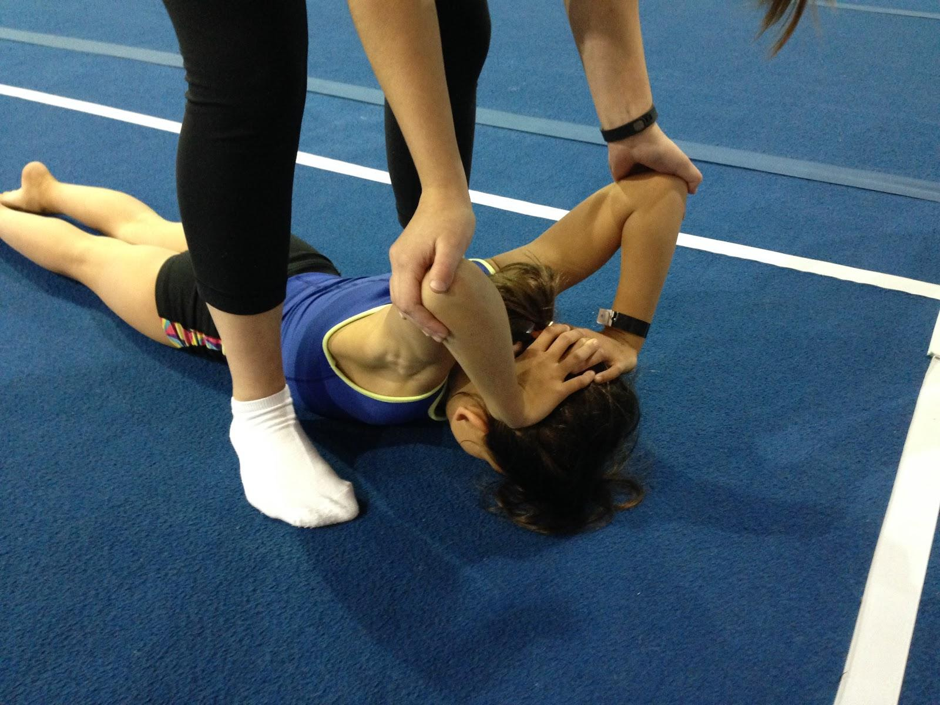

Start with hands on head, arms bent. Lift elbows towards each other, until they feel a stretch.

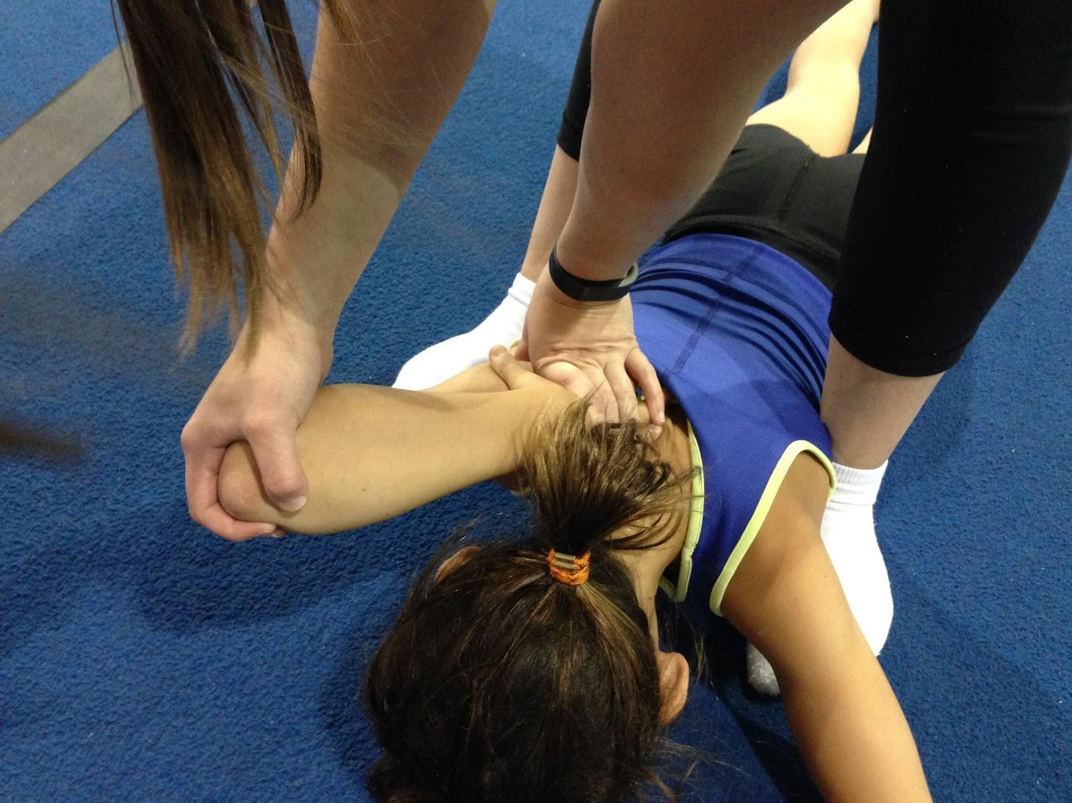Start with arm bent, hand on shoulder blade. Hold hand down, and lift elbow upward, until they feel a stretch. Repeat on the other side.

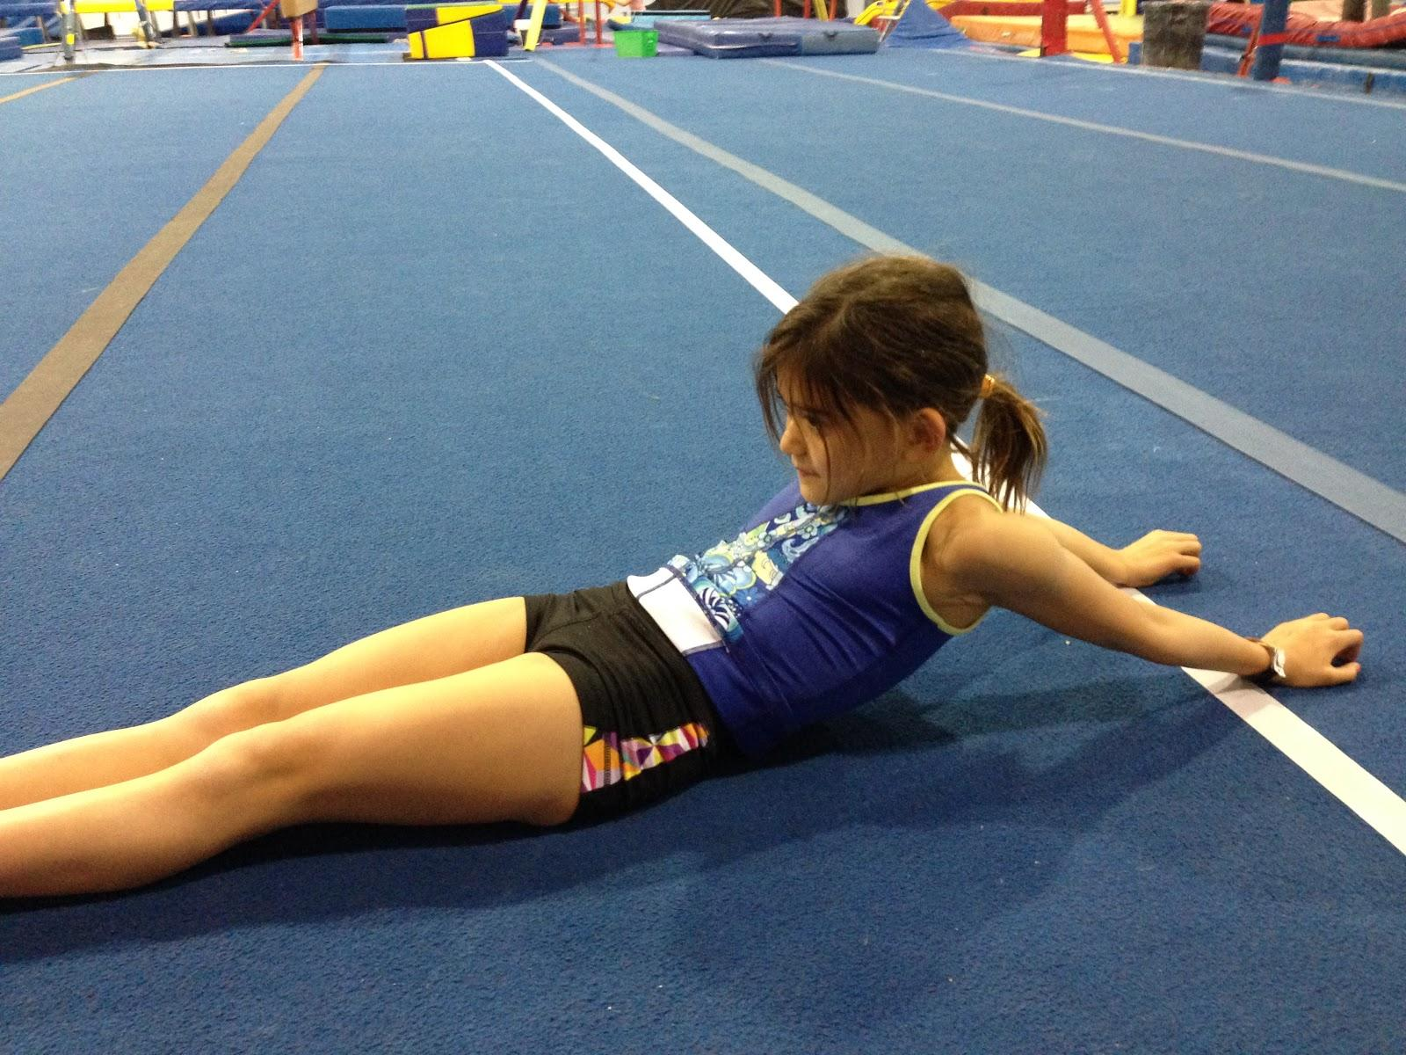

Put arms behind you, and keeping them straight, slide them out as far as you can, until you feel a stretch.

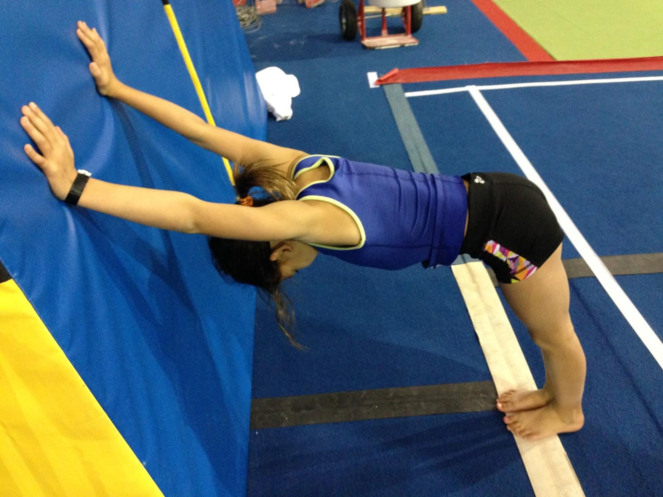

Place hands on wall and stand with feet right below hips, and push shoulders down towards the floor as much as you can, until you feel a stretch.

**\*\*\*Note:** In the assisted shoulder stretches, please make sure to always hold at the elbows. These stretches can be held for 30-60 seconds each.