Contact: Jesse Dickin  Gymnastics Adventure  Phone 306-789-3133  Fax 306-789-3533  jesse@gymadv.ca | 210 Leonard St  Regina, SK S4N 5V7
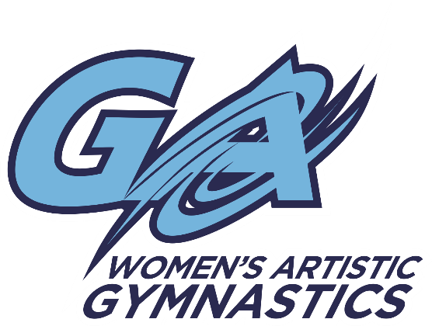

Upcoming Competition

MOOSE JAW GYMTASTIKS

Presents the Luck of the Irish Invitational
Moose Jaw, SK. March 19-20, 2016
Location: Gymtastiks of Moose Jaw
Hillcrest Sport Centre
1599 Main St. N. Moose Jaw, SK. S6J 1L5

WAG: $90.00 J.O. Level 3-7
$55.00 J.O. Level 1-2

Registrations and waiver are due on or before February 1, 2016
- Please make cheques payable to Gymnastics Adventure
- Any registrations received after February 1st will be subject to a $20.00 late fee
- Please see attached in email for waiver. We will also have extras pinned to the bulletin board by the mailboxes at the gym.

- Schedule and session groupings will be released once registration has been received

